import sqlite3 as lite

con = lite.connect('test1.db')

with con:

cur = con.cursor()

cur.execute("DROP TABLE IF EXISTS Cars")

cur.execute("CREATE TABLE Cars(Id INT,Name TEXT,Price INT)")

print("table cars created")

cur.execute("INSERT INTO Cars VALUES(1,'Audi',52642)")

cur.execute("INSERT INTO Cars VALUES(2,'Mercedes',57126)")

print("values in table car inserted")

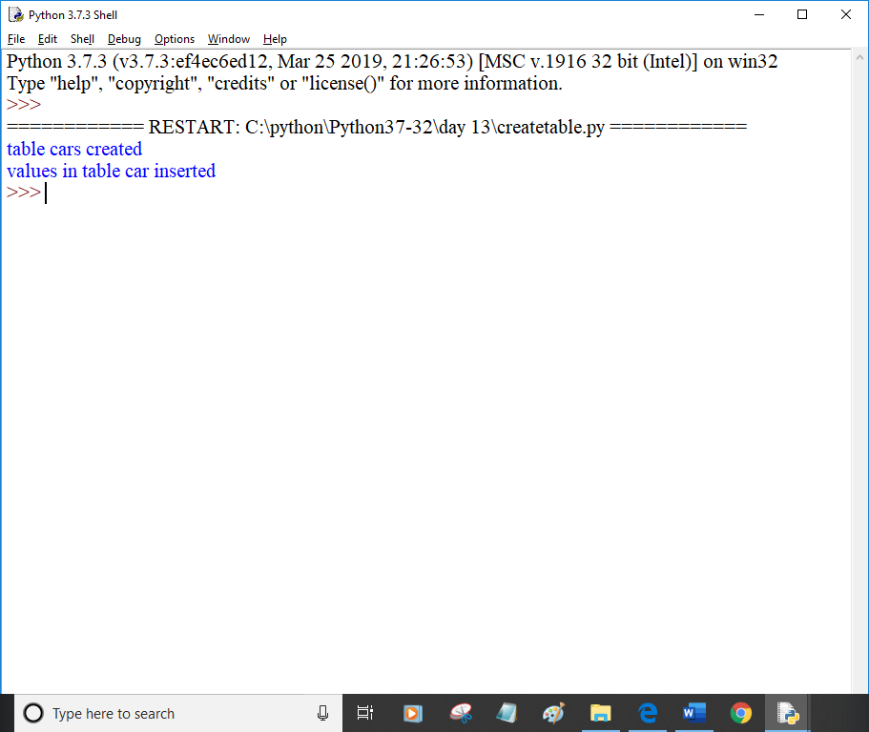

import sqlite3 as lite

con = lite.connect('test1.db')

with con:

cur = con.cursor()

cur.execute("SELECT * FROM Cars")

rows = cur.fetchall()

print(rows)

print('-'*30)

for row in rows:

print(row)

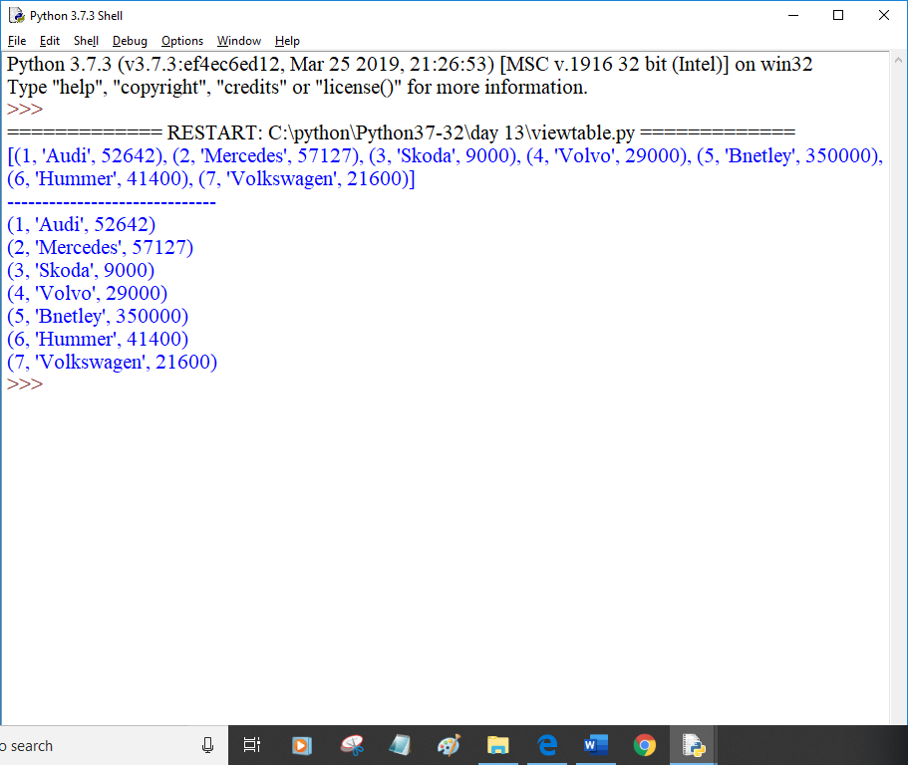

import sqlite3

con = sqlite3.connect('test1.db')

cur = con.cursor()

cur.execute('SELECT SQLITE_VERSION()')

data = cur.fetchone()

print('\n SQLite version',data)

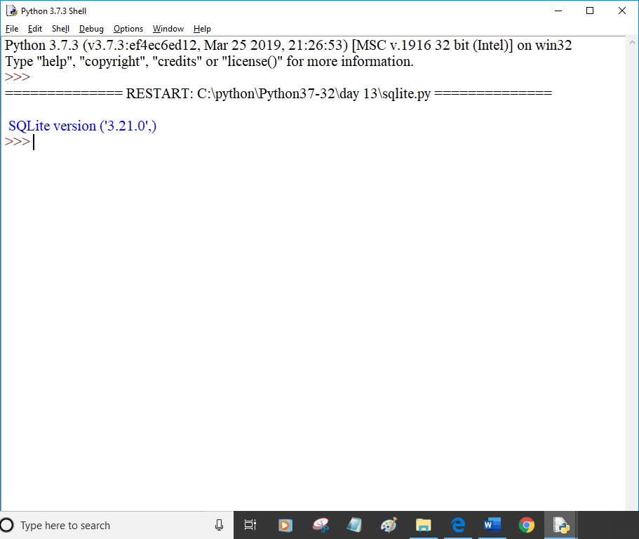

import sqlite3 as lite

import sys

try:

con = lite.connect('test1.db')

cur = con.cursor()

cur.executescript("""

DROP TABLE IF EXISTS Cars;

CREATE TABLE Cars(Id INT, Name TEXT,Price INT);

INSERT INTO Cars VALUES(6,'Citreon',21000);

INSERT INTO Cars VALUES(7,'Hummer', 41400);

INSERT INTO Cars VALUES(8,'Volkswagen', 21600);

""")

con.commit()

except lite.Error as e:

if e:

con.rollback()

print("Error %s:"%e.ags[0])

sys.exit(1)

finally:

if con:

con.close()

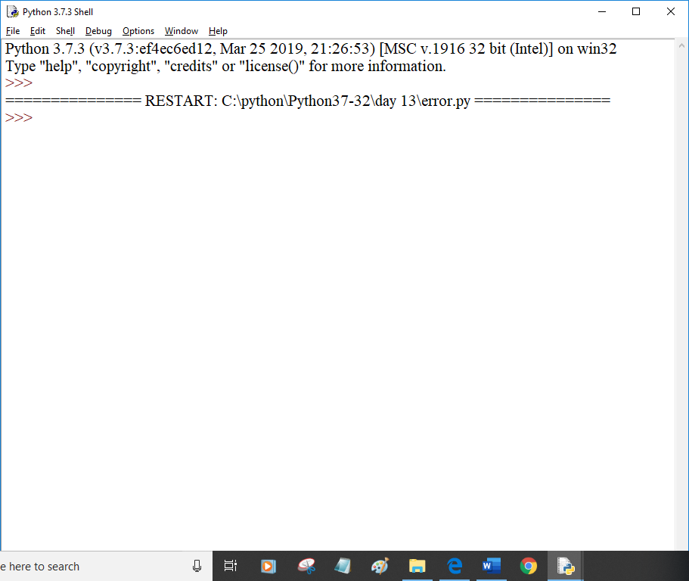

import random

training_data = []

test_data = []

for line in open("iris.txt",'r'):

temp = line[0:-1].split(',')

#print(temp)

if random.random()<=0.8:

training_data.append(temp)

else:

test_data.append(temp)

print("data1",len(training_data))

print("data2",len(test_data))

